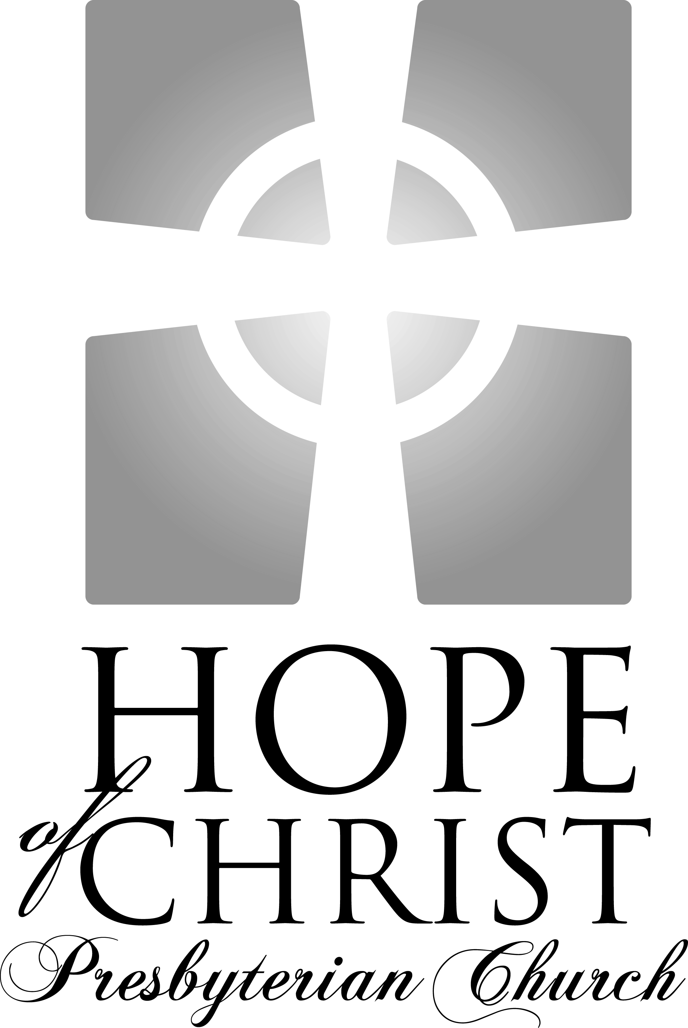

Knowing Jesus Christ Growing in grace
Going into the world with hope

"For to this end we toil and strive, because we have our hope set on the living God, who is the Savior of all people."
I Timothy 4.10

Sunday Service Times:
Adult & Children’s Sunday School: 9:15 – 10:05am
Worship Service: 10:30 – 11:45am

Song of Gathering October 26, 2008

Isaiah 43
Author Unknown

When you pass through the waters, I will be with you.
And the waves, they shall not overcome you

Do not fear, for I have redeemed you
I have called you by name; You are mine
‘
Chorus 1 (2x)
(Men) For I am the Lord Your God
(Women) I am the Lord Your God
(Men) I am the Lord Your God
(Women) I am
(All) I am the Holy One of Israel, Your Savior

Chorus 2
(Men) For I am the Lord
(Women) Do not fear
(Men) I am the Lord
(Women) Do not fear (Repeat)
(All) I am the Lord

When you walk, through the fire, you will not be burned.
And the flames, they shall not, not consume you

Do not fear for I have redeemed you
I have called you by name; You are mine

Chorus 1 (2x)
Chorus 2

Welcome and Announcements

Meditation Psalm 46

God is our refuge and strength, a very present help in trouble. Therefore we will not fear though the earth gives way, though the mountains be moved into the heart of the sea, though its waters roar and foam, though the mountains tremble at its swelling. “Be still, and know that I am God.
I will be exalted among the nations, I will be exalted in the earth!” The Lord of hosts is with us; the God of Jacob is our fortress.
1
Call to Worship

Leader: Lift up your hearts

People: We lift them up to the Lord

Leader: Let us give thanks to the Lord our God

People: Yes, for it is good and right so to do

Leader: It is very good and right and our duty, that we should at
all times, and in all places, give thanks to You, O Lord,
Father Almighty, Everlasting God. Therefore with the
angels and archangels, and with all the hosts of heaven,
we praise and magnify Your glorious name, evermore
praising you and saying:

People: HOLY, HOLY, HOLY, Lord God of hosts.
Heaven and earth are full of Your glory.
Glory be to You, O Lord Most High!

Prayer of Invocation

Songs of Praise

Everlasting God
Music and Lyrics by Brenton Brown, 2005

Strength will rise as we wait upon the Lord,
We will wait upon the Lord
We will wait upon the Lord (2x)

(Pre-Chorus)
Our God, you reign forever
Our hope, our strong deliverer

(Chorus)
You are the everlasting God
The everlasting God
You do not faint, You won't grow weary
You're the defender of the weak
You comfort those in need
You lift us up on wings like eagles

2
At the Name of Jesus
Words by Caroline Noel, 1870, Music by Brian Moss, 2006

At the Name of Jesus, every knee shall bow,
Every tongue confess Him King of glory now;
‘Tis the Father’s pleasure we should call Him Lord,
Who from the beginning was the mighty Word.
At His voice creation sprang at once to sight,
All the angel faces, all the hosts of light,
Thrones and dominations, stars upon their way,
All the heavenly orders, in their vast array.

(Chorus) At the name of Jesus
Every knee shall bow to You
Please the Father, we should call You
Jesus, King and Lord

Humbled for a season, to receive a name
From the lips of sinners unto whom He came,
Faithfully He bore it, spotless to the last,
Brought it back victorious when from death He passed.

In your hearts enthrone Him; there let Him subdue
All that is not holy, all that is not true;
Crown Him as your Captain in temptation’s hour;
Let His will enfold you in its light and power.

(Chorus) At the name of Jesus
Every knee shall bow to You
Please the Father, we should call You
Jesus, King and Lord

Jesus, Lord and Savior, shall return again,
With His Father’s glory, with His angel train;
For all wreaths of empire meet upon His brow,
And our hearts confess Him King of glory now.

(Chorus 2x)

Giving of God’s Tithes and Our Offerings

3
Song of Thanksgiving

Jesus with Thy Church Abide
Words by Thomas Pollock, 1997
Music by Christopher Miner, 1997

Jesus, with Thy church abide;
Be her savior, Lord, and Guide,
While on earth her faith is tried:
We beseech Thee, hear us,
We beseech Thee, hear us.

Keep her life and doctrine pure;
Grant her patience to endure,
Trusting in Thy promise sure:
We beseech Thee, hear us,
We beseech Thee, hear us.

May she one in doctrine be,
One in truth and charity,
Winning all to faith in Thee:
We beseech Thee, hear us,
We beseech Thee, hear us.

May she guide the poor and blind,
Seek the lost until she find
And the brokenhearted bind:
We beseech Thee, hear us,
We beseech Thee, hear us.

Focus on the Kingdom of God

Sermon Pastor Leonard Bailey
(Please see insert)

4
Confession of Faith Nicene Creed
I believe in one God, the Father Almighty, Maker of heaven and earth, and of all things visible and invisible.

And in one Lord Jesus Christ, the only-begotten Son of God, begotten of the Father before all worlds; God of God, Light of Light, very God of very God; begotten, not made, being of one substance with the Father, by whom all things were made.

Who, for us men and for our salvation, came down from heaven, and was incarnate by the Holy Spirit of the virgin Mary, and was made man; and was crucified also for us under Pontius Pilate; He suffered and was buried; and the third day He rose again, according to the Scriptures; and ascended into heaven, and sits on the right hand of the Father; and He shall come again, with glory, to judge the quick and the dead; whose kingdom shall have no end.

And I believe in the Holy Ghost, the Lord and Giver of Life; who proceeds from the Father and the Son; who with the Father and the Son together is worshipped and glorified; who spoke by the prophets.

And I believe in one holy catholic and apostolic Church. I acknowledge one baptism for the remission of sins; and I look for the resurrection of the dead, and the life of the world to come. Amen.

Celebration of Communion
(Please see insert)

Song of Meditation

Why Should I Fear?
Words by William Williams, 1717-1791
Music by Brian T. Murphy and Benj Pocta, 2006

My soul thou art immerged in sin,
So deep that none can trace;
Look to the ransom God decreed
To clear the guilty race

(Chorus)
Had I the guilt of all the world
He’s able to forgive;
Why should I fear? The debt is paid,
If only I believe.

5
The atonement once made on the tree,
Can balance many more
Than all the sins of Adam's race,
If number'd o'er and o'er.

(Chorus)

He paid the mighty sum and died
For sinners yet unborn;
From men, the works of his own hands,
He suffer'd shame and scorn.

(Chorus 2x)

Closing Song

Before the Throne of God Above
Words by Charitie L. Bancroft (1841-1892); Music by Vikki Cook

Before the throne of God above
I have a strong and perfect plea.
A great high Priest whose Name is Love
Who ever lives and pleads for me.
My name is graven on His hands,
My name is written on His heart.
I know that while in Heaven He stands
No tongue can bid me thence depart.

When Satan tempts me to despair
And tells me of the guilt within,
Upward I look and see Him there
Who made an end of all my sin.
Because the sinless Savior died
My sinful soul is counted free.
For God the just is satisfied
To look on Him and pardon me.

Behold Him there the risen Lamb,
My perfect spotless righteousness,
The great unchangeable I AM,
King of glory and of grace,
One with Himself I cannot die.
My soul is purchased by His blood,
My life is hid with Christ on high,
With Christ, my Savior and my God!

Benediction

6
Calendar for this Week:

Today 9:15am Sunday School
10:05am Fellowship & Refreshments
10:30am Worship Service & Communion
6:00pm Berkshire Care Group at the Wood’s home
(Rob Woods, 659-3248)

Monday 7:00pm Stafford Lakes Care Group at the Murphy’s home
(James Murphy, 752-6118)

Thursday 7:00pm Praise Team at the Griffin’s (Pete Griffin, 286-1821)

Friday 7:00pm Edinburgh Care Group at the Jany’s home (Paul Jany, 891-1118)

Saturday 7:00pm Newcomers Dessert at the Bailey’s (Leonard, 645-2880)

**Daylight Savings time ends 2am Sunday morning. Set clocks back one hour**
Upcoming Events:

November 4 Women’s Discipleship. Meets every other Tuesday at 7pm at
the home of Anna Best. Read Chapter 4 of By Design.
(Amy Bailey, 720-4089)

Last Sunday Communion Sunday
Of Month

Nursery Schedule: Katie Murphy, 752-6118

Oct. 26 Sunday School: J. Jany/ Maroneys
Worship: J. Jany/ K. Benke/P. VanHooser

Nov. 2 Sunday School: J. Jany/P. Jany/S. Griffin
Worship: P. Griffin/K. Hamill/A. DiDomenico

Hope of Christ on the web:

Website: HopeofChrist.net
Google Groups: groups.google.com/group/hope-of-christ
Sermons online: sermoncloud.com/hope-of-christ-presbyterian-church
Podcast: phobos.apple.com/WebObjects/MZStore.woa/wa/viewPodcast?id=284700005
Pastor’s Blog: revlen.wordpress.com

Contact Information:

Pastor Leonard Bailey Home Phone: 540-720-4089
Email: Leonard@HopeofChrist.net Mobile Phone: 540-645-2880

CCLI#: 2960788

