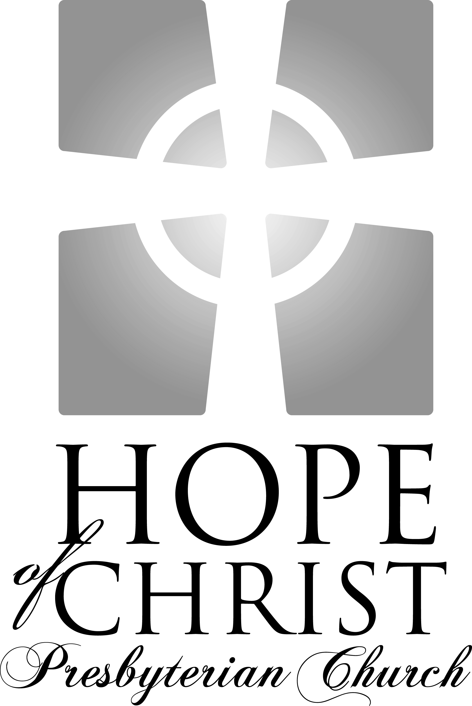

Knowing Jesus Christ Growing in grace
Going into the world with hope

"For to this end we toil and strive, because we have our hope
set on the living God, who is the Savior of all people."
I Timothy 4.10

Sunday Service Times:
Adult & Children’s Sunday School: 9:15 – 10:05am
Worship Service: 10:30 – 11:45am

Song of Gathering December 7, 2008

How Great Is Our God
Words and Music by Chris Tomlin, Jesse Reeves, and Ed Cash, 2004

The splendor of the King clothed in majesty
Let all the earth rejoice, all the earth rejoice
He wraps himself in light and darkness tries to hide
And trembles at His voice, And trembles at His voice

(Chorus)
How great is our God
Sing with me
How great is our God
And all will see
How great, how great is our God

Age to age He stands and time is in His hands
Beginning and the End, Beginning and the End
The Godhead, Three in One; Father, Spirit, Son
The Lion and the Lamb, Lion and the Lamb

Chorus

You’re the name above all names
You are worthy of all praise
My heart will sing how great is our God (2x)

Then sings my soul, my Savior God to Thee
How great Thou art, how great Thou art (2x)

Chorus (2x)

Welcome and Announcements

Meditation Genesis 49:8-12
“Judah, your brothers shall praise you; your hand shall be on the neck of your enemies; your father's sons shall bow down before you. Judah is a lion's cub; from the prey, my son, you have gone up. He stooped down; he crouched as a lion and as a lioness; who dares rouse him? The scepter shall not depart from Judah, nor the ruler's staff from between his feet, until tribute comes to him; and to him shall be the obedience of the peoples. Binding his foal to the vine and his donkey's colt to the choice vine, he has washed his garments in wine and his vesture in the blood of grapes. His eyes are darker than wine, and his teeth whiter than milk.

1
Call to Worship Psalm 122

Leader: I was glad when they said to me, “Let us go to the house of the Lord!” Our feet have been standing within your gates, O Jerusalem!

People: Jerusalem—built as a city that is bound firmly together, to which the tribes go up, the tribes of the Lord, as was decreed for Israel, to give thanks to the name of the Lord.

Leader: There thrones for judgment were set, the thrones of the house of David. Pray for the peace of Jerusalem! “May they be secure who love you! Peace be within your walls and security within your towers!”

People: For my brothers and companions' sake I will say, “Peace be within you!” For the sake of the house of the Lord our God, I will seek your good.

Song of Praise
Angels from the Realms of Glory
Words by James Montgomery, 1816; Music by Henry Smart, 1816

Angels from the realms of glory, wing your flight o'er all the earth;
Ye who sang creation's story, now proclaim Messiah's birth:
(Refrain)
Come and worship, come and worship,
Worship Christ, the newborn King!

Shepherds, in the fields abiding, watching o'er your flocks by night,
God with man is now residing, yonder shines the infant Light;
(Refrain)

Sages, leave your contemplations, brighter visions beam afar;
Seek the great desire of nations, ye have seen His natal star;
(Refrain)

Saints before the altar bending, watching long in hope and fear,
Suddenly the Lord, descending, in His temple shall appear:
(Refrain)

All creation join in praising God the Father, Spirit, Son;
Evermore your voices raising to the eternal Three in One:

(Refrain)

2
Responsive Reading Philippians 2:1-11

Leader: So if there is any encouragement in Christ, any comfort from love, any participation in the Spirit, any affection and sympathy,

People: Complete my joy by being of the same mind, having the same love, being in full accord and of one mind.

Leader: Do nothing from rivalry or conceit, but in humility count others more significant than yourselves.

People: Let each of you look not only to his own interests, but also to the interests of others.

Leader: Have this mind among yourselves, which is yours in Christ Jesus,

People: Who, though He was in the form of God, did not count equality with God a thing to be grasped,

Leader: But made Himself nothing, taking the form of a servant, being born in the likeness of men.

People: And being found in human form, He humbled Himself by becoming obedient to the point of death, even death on a cross.

Leader: Therefore God has highly exalted Him and bestowed on Him the name that is above every name,

People: So that at the name of Jesus every knee should bow, in heaven and on earth and under the earth, and every tongue confess that Jesus Christ is Lord, to the glory of God the Father.

Song of Confession
Away in a Manger
Author Unknown, 1885; Music by William Kirkpatrick, 1895
Away in a manger, no crib for His bed
The little Lord Jesus laid down His sweet head
The stars in the bright sky looked down where He lay
The little Lord Jesus asleep on the hay
Be near me, Lord Jesus, I ask Thee to stay
Close by me forever and love me I pray
Bless all the dear children in Thy tender care
And take us to heaven to live with Thee there

3
Assurance of Pardoning Grace
But when the fullness of time had come, God sent forth his Son, born of woman, born under the law, to redeem those who were under the law, so that we might receive adoption as sons. And because you are sons, God has sent the Spirit of His Son into our hearts, crying, “Abba! Father!” So you are no longer a slave, but a son, and if a son, then an heir through God.”
Giving of God’s Tithes and Our Offerings
Lighting of the Second Advent Candle

Song of Thanksgiving

Silent Night, Holy Night
Words by Joseph Mohr, 1816; Music by Franz Xavier Gruber, 1818
(Translation by Joseph Freeman Young, 1863)

Silent night! Holy night!
All is calm, all is bright
Round yon virgin mother and child.
Holy infant so tender and mild,
Sleep in heavenly peace,
Sleep in heavenly peace.
Silent night! Holy night!
Shepherds quake at the sight!
Glories stream from heaven afar,
Heavenly hosts sing alleluia!
Christ, the Savior is born!
Christ, the Savior is born!
Silent night! Holy night!
Son of God, love's pure light
Radiant beams from Thy holy face,
With the dawn of redeeming grace,
Jesus, Lord at Thy birth!
Jesus, Lord at Thy birth !

Silent night! Holy night!
Wondrous star, lend thy light;
With the angels let us sing
Alleluia to our King;
Christ, the Savior is born!
Christ, the Savior is born!

4
Sermon Pastor Leonard Bailey
Matthew 1:1-17 Page 807

What’s Your Name? Who’s Your Daddy? (Is He rich like me?)

The Gospel According to Matthew: “The King and His Kingdom”

The Christ

The Genealogy

Promised Messiah

Rightful King

Savior of Sinners

5
Song of Response

Hark, the Herald Angels Sing
Words by Charles Wesley, 1739; Music by William Cumming, 1840

Hark! the herald angels sing, "Glory to the newborn King!
Peace on earth and mercy mild, God and sinners reconciled"
Joyful, all ye nations rise, join the triumph of the skies;
With the angelic host proclaim: "Christ is born in Bethlehem"
Hark! the herald angels sing, "Glory to the newborn King!"
Christ by highest heav'n adored, Christ the everlasting Lord!
Late in time behold Him come, offspring of the Virgin's womb,
Veiled in flesh the Godhead see, hail the incarnate Deity;
Pleased as man with men to dwell, Jesus, our Emmanuel.
Hark! the herald angels sing, "Glory to the newborn King!"
Hail the heav'n-born Prince of Peace! Hail the Son of Righteousness!
Light and life to all He brings, ris'n with healing in His wings.
Mild He lays His glory by, born that man no more may die,
Born to raise the sons of earth, born to give them second birth.
Hark! the herald angels sing, "Glory to the newborn King!"

Benediction

6
Calendar for this Week:

Today 9:15am Sunday School
10:05am Fellowship & Refreshments
10:30am Worship Service
6:00pm Berkshire Care Group at the Woods’ home
(Rob Woods, 540-659-3248)
No Edinburgh Care Group tonight

Monday 7:30pm Stafford Lakes Care Group at the Murphy’s home
(James Murphy, 540-752-6118)

Thursday 7:00pm Prayer and Praise time at the Griffin’s (Pete, 540-286-1821)

Saturday 7:30am Men’s Discipleship Kickoff Breakfast at Jimmy the
Greek Restaurant, 225 Garrisonville Rd. All men are
encouraged to attend. (Leonard, 540-645-2880)

11:00am Baby Shower for Karen Benke at Katie Maroney’s home
(Katie, 540-659-1048)

Upcoming Events:

December 14 Potluck & Christmas Caroling at the Wood’s, 5pm. All are invited.
(Rob, 540-659-3248)
December 14 Stafford Lakes Care Group Progressive Dinner, 6-9pm.
(James Murphy, 540-752-6118)
December 16 Women’s Christmas Ornament Exchange at the Amber House Tea
Room at 7pm. $15 per person. Please RSVP by 12/11 to Amy Bailey, 540-720-4089.
December 24 Christmas Eve Service at New Life in Christ Church followed by a
Christmas Open House at the Bailey’s home.
.
Nursery Schedule: Katie Murphy, 540-752-6118

Dec. 7 Sunday School: J. Jany S. Gensimore/S. Griffin **Be there by 9:00 am
Worship: K. Murphy/P. VanHooser/M. Davis **Be there by 10:15 am

Dec. 14 Sunday School: J. Jany/K. Benke/W. Turner
Worship: P. Griffin/E. Garner/M. Turner

Birthdays/Anniversaries this week:
12/12—Phillip Allan 12/7—Larry & Peggy VanHooser
12/13—Justin Best
Hope of Christ on the web:

Website: HopeofChrist.net
Google Groups: groups.google.com/group/hope-of-christ
Sermons online: sermoncloud.com/hope-of-christ-presbyterian-church
Podcast: phobos.apple.com/WebObjects/MZStore.woa/wa/viewPodcast?id=284700005

Contact Information:

Pastor Leonard Bailey Home Phone: 540-720-4089
Email: Leonard@HopeofChrist.net Mobile Phone: 540-645-2880

CCLI # 2960788

