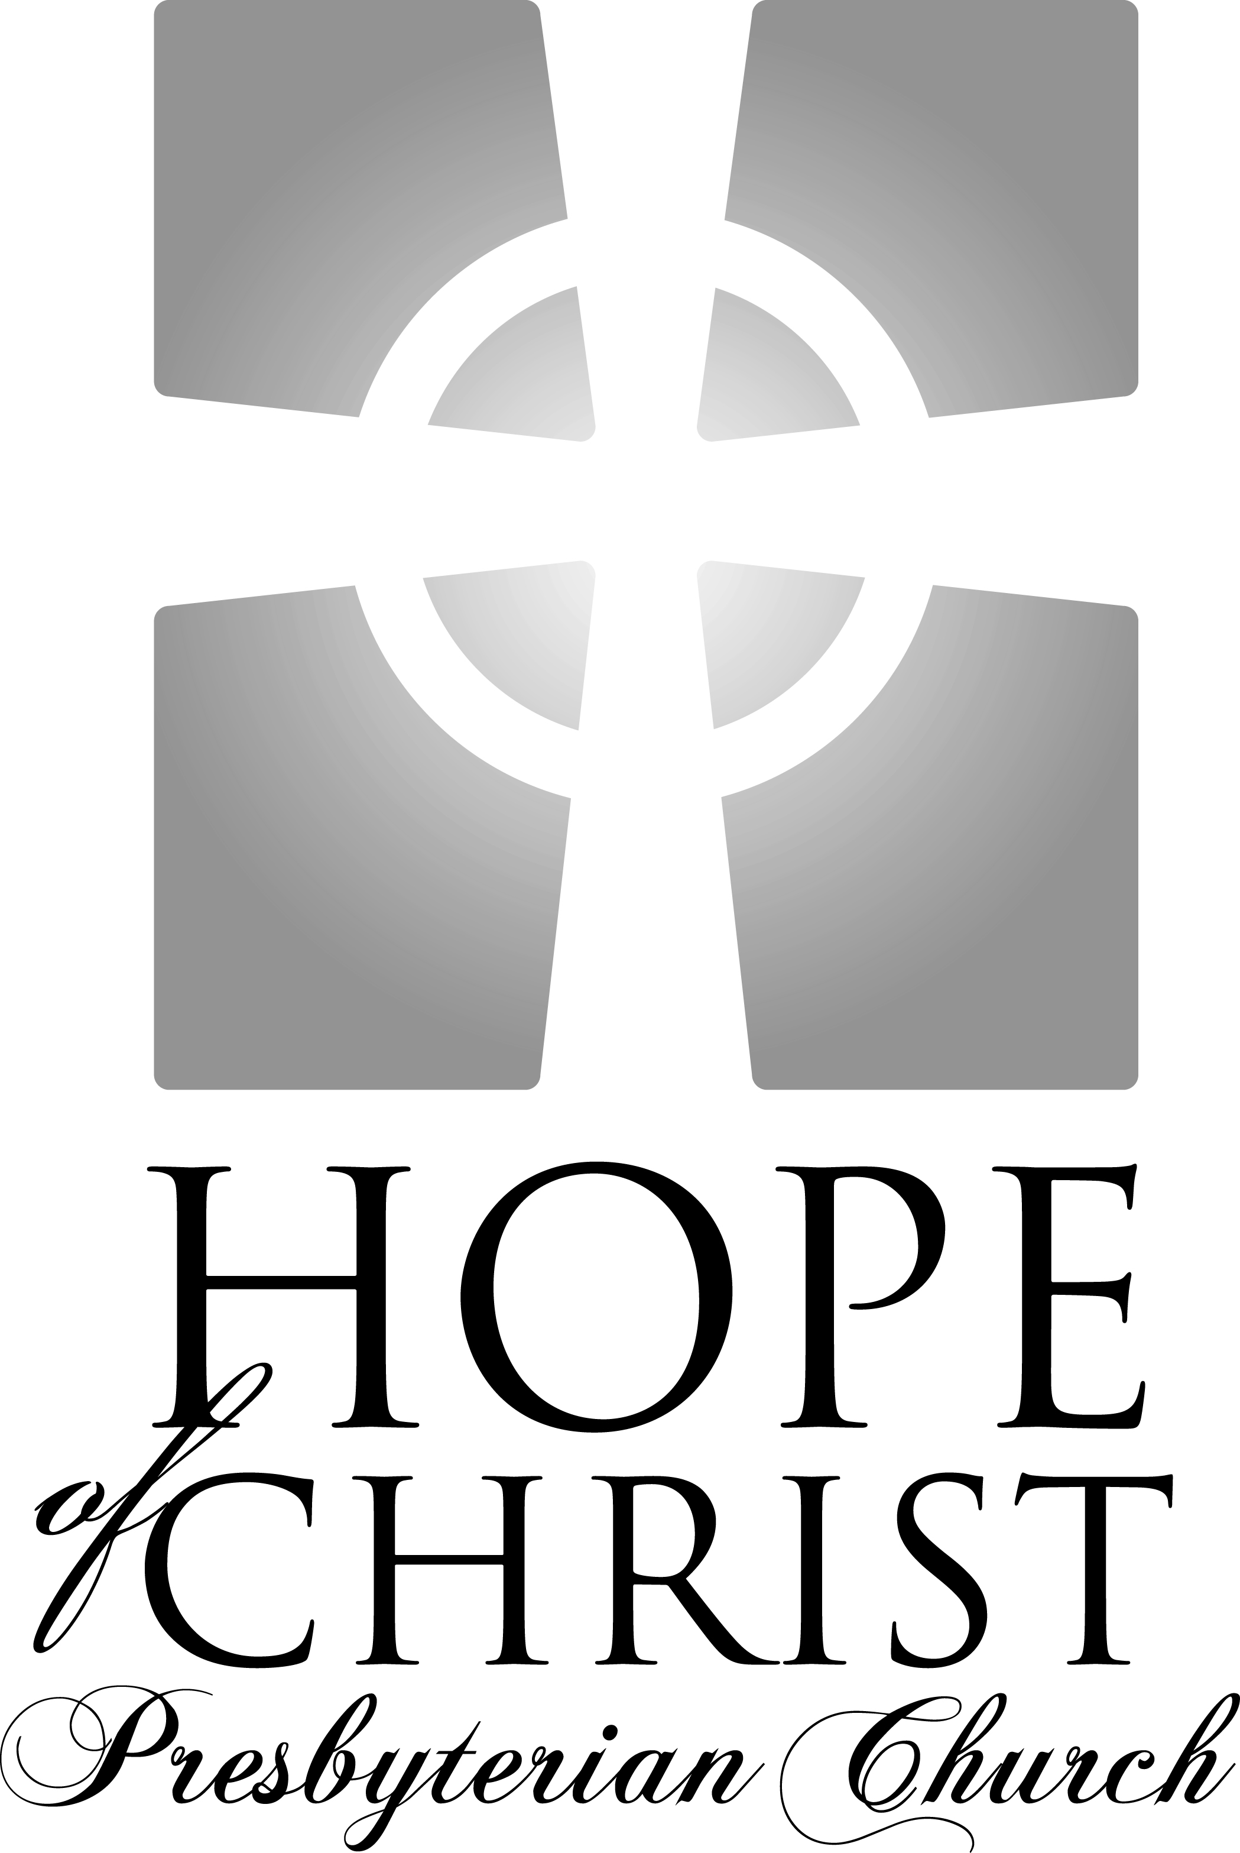

Knowing Jesus Christ Growing in grace
Going into the world with hope

"For to this end we toil and strive, because we have our hope
set on the living God, who is the Savior of all people."
I Timothy 4.10

Sunday Service Times:
Adult & Children’s Sunday School: 9:15 – 10:05am
Worship Service: 10:30 – 11:45am

Song of Gathering November 30, 2008

For the Beauty of the Earth
Words by Folliot S. Pierpont, 1864; Music by Conrad Kocker, 1838

For the beauty of the earth, for the glory of the skies;
For the love which from our birth, over and around us lies;
Lord of all, to thee we raise this, our hymn of grateful praise.

For the beauty of each hour, of the day and of the night
Hill and vale and tree and flow'r, sun and moon, and stars of light;
Lord of all, to thee we raise this, our hymn of grateful praise.

For the joy of ear and eye, for the heart and mind's delight;
For the mystic harmony, linking sense to sound and sight;
Lord of all, to thee we raise this, our hymn of grateful praise.

For the joy of human love – brother, sister, parent, child;
Friends on earth and friends above, for all gentle thoughts and mild;
Lord of all, to thee we raise this, our hymn of grateful praise.

For each perfect gift of Thine to our race so freely given,
Graces human and divine, flowers of earth and buds of heaven;
Lord of all, to thee we raise this, our hymn of grateful praise.

Welcome and Announcements

Meditation Isaiah 40:1-5
Comfort, comfort my people, says your God. Speak tenderly to Jerusalem, and cry to her that her warfare is ended, that her iniquity is pardoned, that she has received from the Lord's hand double for all her sins. A voice cries: “In the wilderness prepare the way of the Lord; make straight in the desert a highway for our God. Every valley shall be lifted up, and every mountain and hill be made low; the uneven ground shall become level, and the rough places a plain. And the glory of the Lord shall be revealed, and all flesh shall see it together, for the mouth of the Lord has spoken.”
Call to Worship

Leader: I lift up my eyes to the hills. From where does my help come?
My help comes from the Lord, maker of heaven and earth.

People: He will not let your foot be moved; He who keeps you
will not slumber. Behold He who keeps Israel will
neither slumber nor sleep.

Leader: The Lord is your keeper; the Lord is your shade on your right
hand. The sun shall not strike you by day, nor the moon by night.

1
People: The Lord will keep you from all evil; He will keep your
life. The Lord will keep your going out and your coming in from this time forth and forevermore.

Songs of Praise

Jesus Messiah
Words and Music by Chris Tomlin, Ed Cash & Jesse Reeves, 2008

He became sin Who knew no sin
That we might become His righteousness
He humbled himself and carried the cross
Love so amazing, love so amazing

(Chorus)
Jesus Messiah, Name above all names
Blessed Redeemer, Emmanuel
The rescue for sinners
The ransom from Heaven
Jesus Messiah, Lord of all

His body the bread, His blood the wine
Broken and poured out all for love
The whole earth trembled and the veil was torn
Love so amazing, love so amazing

Chorus

All our hope is in You
All our hope is in You
All the glory to You, God
The Light of the world

Chorus

Great is Thy Faithfulness
Words by Thomas O. Chisholm, 1923, Music by William M. Runyan, 1923

Great is Thy faithfulness, O God my Father;
There is no shadow of turning with Thee;
Thou changest not, Thy compassions, they fail not;
As Thou hast been, Thou forever will be.

(Chorus)
Great is Thy faithfulness!
Great is Thy faithfulness!
Morning by morning new mercies I see.
All I have needed Thy hand hath provided;
Great is Thy faithfulness, Lord, unto me!

2
Summer and winter and springtime and harvest,
Sun, moon and stars in their courses above
Join with all nature in manifold witness
To Thy great faithfulness, mercy and love.

(Chorus)

Pardon for sin and a peace that endureth
Thine own dear presence to cheer and to guide;
Strength for today and bright hope for tomorrow,
Blessings all mine, with ten thousand beside!

(Chorus)

Giving of God’s Tithes and Our Offerings

Lighting of the First Advent Candle

Song of Thanksgiving

Come Thou Long Expected Jesus
Words by Charles Wesley, 1707-1788, Music by Rowland H. Pritchard

Come, Thou long expected Jesus, born to set Thy people free;
From our fears and sins release us, let us find our rest in Thee.
Israel's strength and consolation, hope of all the earth Thou art;
Dear desire of every nation, joy of every longing heart.

Joy to those who long to see Thee, Dayspring from on high, appear
Come, Thou promised Rod of Jesse. Of Thy birth we long to hear!
O'er the hills the angels singing news, glad tidings of a birth;
“Go to Him, your praises bringing; Christ the Lord has come to earth.”

Come to earth to taste our sadness, He whose glories knew no end;
By His life He brings us gladness, Our Redeemer, Shepherd, Friend.
Leaving riches without number, born within a cattle stall;
This the everlasting wonder, Christ was born Lord of All.

Born Thy people to deliver, born a child and yet a king,
Born to reign in us forever, now Thy gracious kingdom bring.
By Thine own eternal spirit rule in all our hearts alone;
By Thine all sufficient merit, raise us to Thy glorious throne.

3
Sermon Pastor Leonard Bailey
Zechariah 8:19 Page 796

From Fasting to Feasting in Zero Easy Steps

Confession of Faith Heidelberg Catechism
What is thy only comfort in life and death?
That I with body and soul, both in life and death, am not my own, but belong unto my faithful Saviour Jesus Christ; who, with his precious blood, has fully satisfied for all my sins, and delivered me from all the power of the devil; and so preserves me that without the will of my heavenly Father, not a hair can fall from my head; yea, that all things must be subservient to my salvation, and therefore, by his Holy Spirit, He also assures me of eternal life, and makes me sincerely willing and ready, henceforth, to live unto him.

5
Celebration of Communion

Invitation to the Lord’s Table

Communion, also called The Lord’s Supper or the Eucharist, is the family meal of Christians. We invite all committed followers of Jesus Christ to partake of this sacrament: those who are baptized members of a congregation that proclaims the gospel, who are at peace with God and with their neighbor, and who seek strength to live more faithfully for
Christ. If you are not a Christian, or if you are not prepared to share in this meal, we encourage you to spend this time in prayer. We hope that this time is helpful to you as you consider your relationship with Jesus Christ and with His people, the church. Note: Hope of Christ Presbyterian
Church uses wine in this celebration. If, whether for reasons of health or conscience, you prefer grape juice it is provided in the outer ring of cups.

Prayers of Meditation for Those Not Communing
If you are not able to receive Communion, please use this time to meditate on one of the following prayers.
Prayer for Those Searching for Truth
Lord Jesus, you claim to be the way, the truth, and the life. Grant that I might be undaunted by the cost of following you as I consider the reasons for doing so. If what you claim is true, please guide me, teach me, and open to me the reality of who you are. Give me an understanding of you that is coherent, convincing, and that leads to the life that you promise. Amen.
Prayer of Belief
Lord Jesus, I admit that I am weaker and more sinful than I ever before believed, but through you I am more loved and accepted than I ever dared hope. I thank you for paying my debt, bearing my punishment on the cross, and offering forgiveness and new life. Knowing that you have been raised from the dead, I turn from my sins and receive you as Savior and Lord. Amen. (If you are praying this today for the first time, please share this with the Pastor after the service).
Prayer of Commitment
Lord Jesus, you have called us to follow you in baptism and in a life of committed discipleship in your church. Grant that I may take the necessary steps to be one with your people, and live in the fullness of your Spirit.
Amen.

Song of Response

O Come O Come Emmanuel
Words by John M. Neale, 1851, Music by Thomas Helmore, 1856

O come, O come Emmanuel
And ransom captive Israel
That mourns in lonely exile here
Until the Son of God appear
Rejoice! Rejoice! Emmanuel
Shall come to thee, O Israel.

O come o come, Thou Lord of might
Who to Thy tribes, on Sinai's height,
In ancient times did'st give the Law,
In cloud, and majesty and awe.
Rejoice! Rejoice! Emmanuel
Shall come to thee, O Israel.

O come, Thou Rod of Jesse, free
Thine own from Satan's tyranny.
From depths of hell Thy people save
And give them victory o'er the grave!
Rejoice! Rejoice! Emmanuel
Shall come to thee, O Israel.

O come, Thou Key of David,
Come and open wide our heavenly home
Make safe the way that leads on high,
And close the path to misery.
Rejoice! Rejoice! Emmanuel
Shall come to thee, O Israel.

O come, Thou Dayspring from on high
And cheer us by Thy drawing nigh;
Disperse the gloomy clouds of night
And death's dark shadow put to flight.
Rejoice! Rejoice! Emmanuel
Shall come to thee, O Israel.

Benediction

6
Calendar for this Week:

Today 9:15am Sunday School
10:05am Fellowship & Refreshments
10:30am Worship Service & Communion
12:30pm Potluck lunch at H.H. Poole
6:00pm Edinburgh Care Group at the Jany’s home
(Paul Jany, 540-891-1118)
*No Berkshire Care Group tonight

Monday 7:30pm Stafford Lakes Care Group at the Murphy’s home
(James Murphy, 540-752-6118)

Tuesday 7:00pm Women’s Discipleship at Kali Hamill’s home. Reread
Chapter 5 of By Design. (Amy Bailey, 540-720-4089)

Thursday 7:00pm Praise Team Practice at the Griffin’s (Pete, 540-286-1821)

Upcoming Events:

December 13 Men’s Discipleship breakfast, 7:30am at Jimmy the Greek Restaurant.
(Leonard Bailey, 540-645-2880)
December 13 Baby Shower for the Benke’s. (Katie Maroney, 540-659-1048)
December 14 Potluck & Christmas Caroling at the Wood’s (Rob, 540-659-3248)
December 16 Women’s Christmas Ornament Exchange at the Amber House
Tea Room at 7pm. $15 per person. (Amy Bailey, 540-720-4089)
December 24 Christmas Eve Service at New Life in Christ Church followed by a
Christmas Open House at the Bailey’s home.
.
Nursery Schedule: Katie Murphy, 540-752-6118

Nov. 30 Sunday School: J. Jany/P. Jany
Worship: A. Bailey/S. Leino/R. Bailey

Dec 7 Sunday School: J. Jany/S. Gensimore/S. Griffin
Worship: K. Murphy/P. VanHooser/M. Davis

Hope of Christ on the web:

Website: HopeofChrist.net
Google Groups: groups.google.com/group/hope-of-christ
Sermons online: sermoncloud.com/hope-of-christ-presbyterian-church
Podcast: phobos.apple.com/WebObjects/MZStore.woa/wa/viewPodcast?id=284700005

Contact Information:

Pastor Leonard Bailey Home Phone: 540-720-4089
Email: Leonard@HopeofChrist.net Mobile Phone: 540-645-2880

CCLI # 2960788

